OPENAI CHATBOT
LLM:
It is a Large Language Model.
It has the capability to understand and generate human-like test.
We chose openapi key and our model is -gpt4o-mini.
It is a pre-trained model, using this we can classify new data instantly.

Packages:
- Streamlit:creates web interface for chatbot
- Langchain:it is used to connect language models like gtp
- Langchain-openai:it helps to use openai models .Here,we used gpt-4o.
- openai:It is a official openai python library
Objectives:
- To design a chatbot using ChatOpenAI API
- To build a simple user-interface using streamlit
- We use conversation chain for creating conversation memory
- ConversationBufferMemory stores the chat history
Procedure:
- First we created a secret openai key and saved it using .toml extension in .streamlit folder
- User enters input text on streamlit interface
- The text is send to conversation chain
- The ChatOpenAI model generates a reply
- ConversationBufferMemory stores the chat history
- The chatbot displays responses and shows full chat history.

Source Code:
import streamlit as st
from langchain_openai import ChatOpenAI from langchain.chains import ConversationChain from langchain.memory import ConversationBufferMemory import os

# --- Streamlit Setup ---
st.set_page_config(page_title="OpenAI Chatbot") st.title(" OpenAI GPT Chatbot")

# --- Get API Key ---
openai_api_key = os.getenv("OPENAI_API_KEY") or st.secrets.get("OPENAI_API_KEY") if not openai_api_key:
st.error(" Please set your OpenAI API key in environment variables or Streamlit secrets.")
st.stop()

# --- Initialize LLM ---
llm = ChatOpenAI(
model="gpt-4o-mini", # Or "gpt-4-turbo", "gpt-5" api_key=openai_api_key
)

# --- Memory --- if "memory" not in st.session_state:
st.session_state.memory = ConversationBufferMemory(return_messages=True)

# --- Conversation Chain --- conversation = ConversationChain(
llm=llm,
memory=st.session_state.memory, verbose=False
)

# --- User Input --- user_input = st.text_input("You:", key="input")

if user_input:
try:
response = conversation.run(input=user_input)
# Add messages to memory explicitly st.session_state.memory.chat_memory.add_user_message(user_input) st.session_state.memory.chat_memory.add_ai_message(response) st.markdown(f"**Bot:** {response}") except Exception as e: st.error(f"Error: {e}")

# --- Chat History --- if st.checkbox("Show Chat History"):
for msg in st.session_state.memory.chat_memory.messages:
role = "User" if msg.type == "human" else "Bot" st.markdown(f"**{role}:** {msg.content}")
Output:
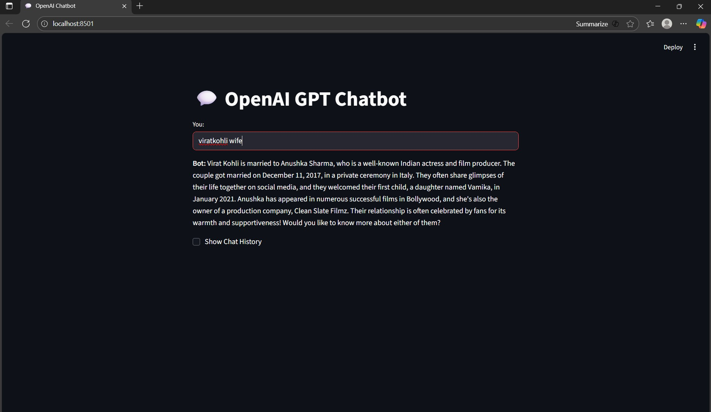

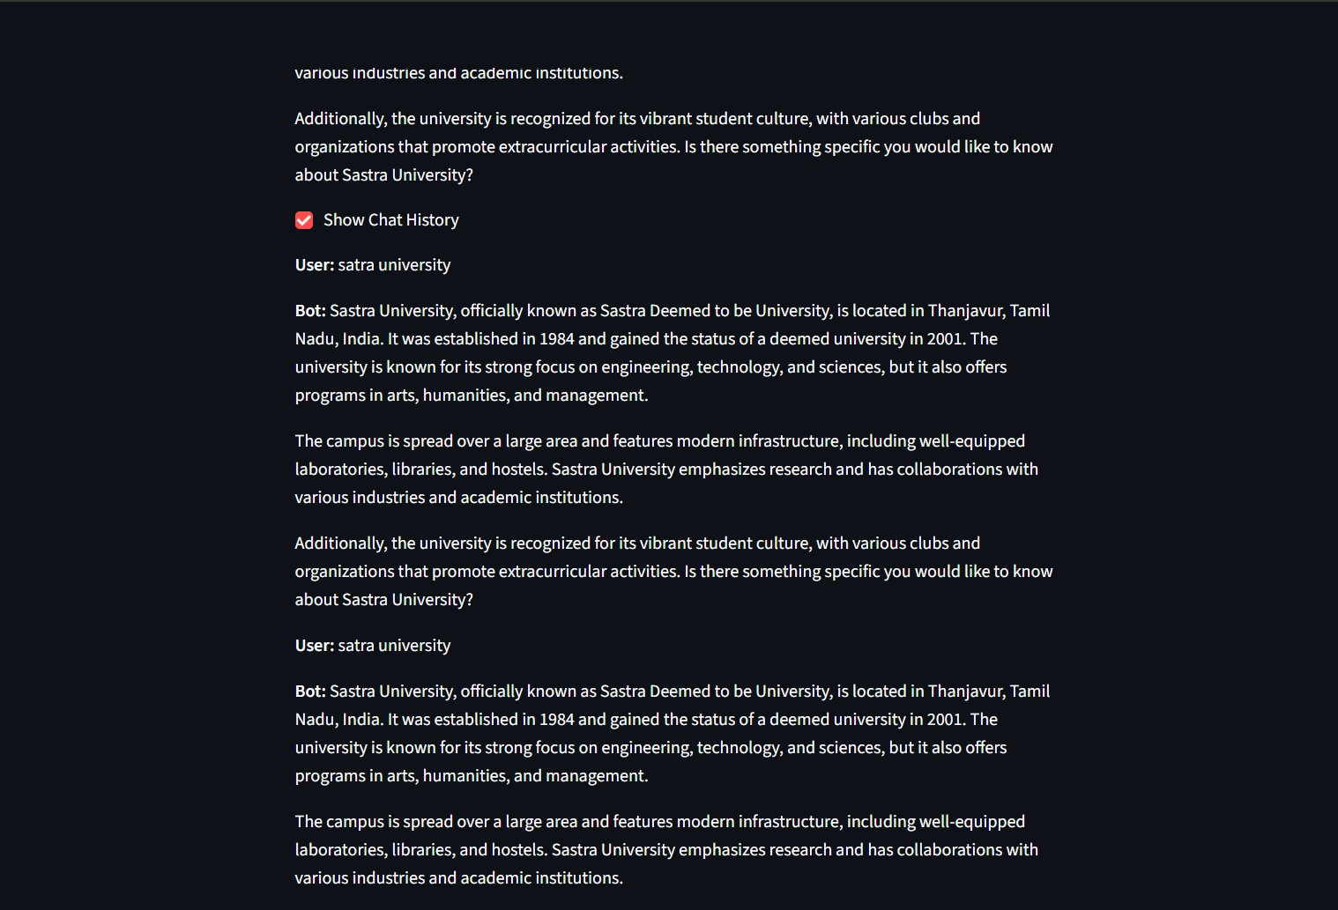
Conclusion:
The project successfully demonstrates how OpenAI GPT models can be integrated into a Streamlit web app using LangChain. It provides real-time interaction with conversation memory and a clean interface. This project helped in understanding API usage, Python integration, and Ul development.

